Varianta 13.

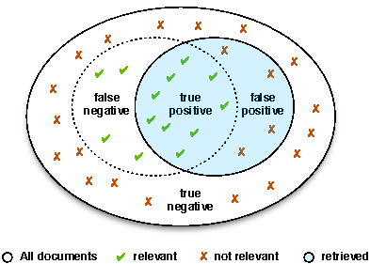

True Positive=9

False Negative=4

False Positive=4

True Negative=18

Precision=True Positive/(True Positive+False positive)=9/(9+4)=9/13

Recall=True positive/(True Positive+False Negative)=9/(9+18)=1/3